Calculus Section 10.4 Polar Coordinates and Graphs

Rectangular coordinates are in the form .

Polar coordinates are in the form .

________________________________________________________________________________

Ex. 1 Graph the following polar coordinates:

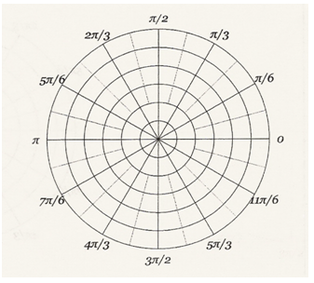



_______________________________________________________________________________

In Precalculus you learned that:

 so *x* =

 so *y* =



 so *r* =

________________________________________________________________________________

Ex. Convert  to rectangular coordinates.

________________________________________________________________________________

Ex. Convert  to polar coordinates.

Ex. Convert the following equations to polar form.

(a) *y* = 4 (b) 

________________________________________________________________________________

Ex. Convert the following equations to rectangular form, and sketch the graph.

(a)  (b)  (c) 



__________________________________________________________________________________

**CALCULUS**

To find the slope of a tangent line to a polar graph , we can use the facts that , together with the product rule:



__________________________________________________________________________________Ex. Find  and the slope of the graph of the polar curve at the given value of .

