Calculus Section 4.3 Properties of Definite Integrals
-Evaluate a definite integral using properties of definite integrals
Page 273 #’s 13, 15, 23, 26, 39-41, 44, 47-49, 61-64
An indefinite integral is used to find the ____________________ of a function.
The definite integral is used to notate finding the _____________________________.
Definite Integral
If the function f is continuous on the closed interval [a, b], then the area of the region bounded by the graph of f and the x-axis is:
$$Area=\int_{a}^{b}{f\left(x\right)dx}$$where a and b are the endpoints of the region whose area you are finding.
The value of a is always the left most (smallest value) of the interval. For instance, the area under the curve bounded by [3, 7] will have a = 3 and b = 7: $Area=\int_{3}^{7}{f\left(x\right)dx}$.
The definite integral is an accumulator of area. This means that the area adds to its value as it moves from _________ to _________.
If the value of b is smaller than the value of a, then the area is moving ___________ and will be ___________.
$$\int_{b}^{a}{f\left(x\right)dx}=-\int_{a}^{b}{f\left(x\right)dx} or the put numbers to it \int_{4}^{1}{f\left(x\right)dx}=-\int_{1}^{4}{f\left(x\right)dx}$$
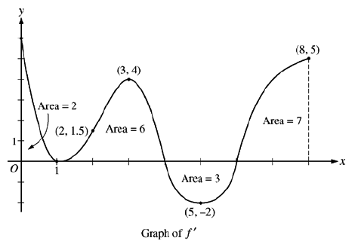
Areas above the x-axis are considered _____________ while areas under the x-axis are _______________. This means that a negative area while moving right-to-left would be counted as ______________.
Example)
$\int_{0}^{1}{f\left(x\right)dx}=$
$\int_{0}^{4}{f\left(x\right)dx}=$
$\int_{1}^{6}{f\left(x\right)dx}=$
$\int_{4}^{8}{f\left(x\right)dx}=$
$\int_{0}^{8}{f\left(x\right)dx}=$
$\int_{4}^{1}{f\left(x\right)dx}=$
If f(8) = 4, determine the absolute minimum value of f on the closed interval 0 ≤ x ≤ 8.

Properties of Definite Integrals
- If f is defined at x = a, then $\int_{a}^{a}{f\left(x\right)dx}=$
- If f is integrable on the entire interval [a, b] and c is a value such that a < c < b, then $\int_{a}^{b}{f\left(x\right)dx=}\int_{a}^{c}{f\left(x\right)dx}+\int_{c}^{b}{f\left(x\right)dx}$
- $\int_{a}^{b}{k∙f\left(x\right)dx}=$
- $\int_{a}^{b}{\left(f\left(x\right)+g\left(x\right)\right)dx}=$
- If f(x) is an even function, then $\int_{-a}^{a}{f\left(x\right)dx}=$
- If f(x) is an odd function, then $\int_{-a}^{a}{f\left(x\right)dx}=$
Example) $\int_{2}^{4}{f\left(x\right)dx}=5$ and $\int_{2}^{6}{f\left(x\right)dx}=-6$. What is the value of $\int_{4}^{6}{f\left(x\right)dx}$?

Example) $\int_{1}^{3}{x^{2}dx=\frac{26}{3}}$, $\int_{1}^{3}{xdx}=4$, and $\int_{1}^{3}{dx}=2$. Evaluate $\int_{1}^{3}{\left(-x^{2}+4x-3\right)dx}$.

