Calculus Section 4.3 Riemann Sums  
-Understand the definition of a Riemann Sum  
-Use Riemann Sums to find the area under a curve

Homework: Riemann Sum worksheet

How do you find the area under a graph?

If it is a piecewise graph made from linear functions and portions of circles, then you can split the graph into geometric shapes.

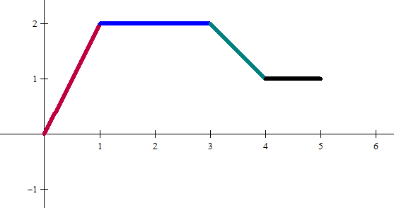

What if the graph was curved?

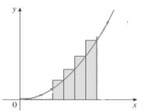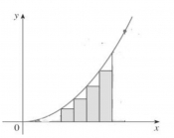

Right Riemann: the height of each rectangle comes from the right side.

Left Riemann: the height of each rectangle comes from the left side.

The most common way is to use rectangles.

If the function is increasing, then the left Riemann sum is an underestimate and the right is an overestimate.

If the function is decreasing, then the left Riemann sum is an overestimate and the right is an underestimate.

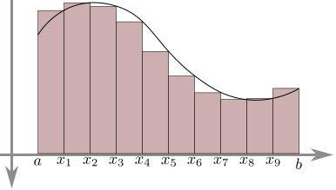How do we get better and better estimates?

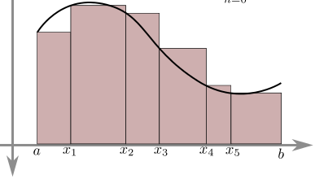

Use narrower and more rectangles.

Area of each rectangle is:

Area = f(x)∆x

∆x

f(x)

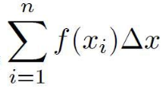  
If there are n rectangles and we add them up:

f(x1)∆x + f(x2)∆x + f(x3)∆x + … + f(xn – 1)∆x + f(xn)∆x =

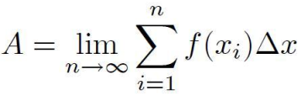The approximation is best if ∆x is infinitely small:

This is the limit definition of the integral.

Ex) Use a left and right Riemann sum to approximate the area under y = -x2 + 2 from (0, 1) using 4 intervals.



Use left and right Riemann sums to approximate the area under the curve f(t).

|  |  |  |  |  |  |
| --- | --- | --- | --- | --- | --- |
| t | 0 | 2 | 5 | 7 | 8 |
| f(t) | 0 | 4 | 13 | 21 | 23 |