Calculus Section 4.4 Mean Value and 2nd Fund. Thm of Calculus  
-Understand and use the Mean Value Theorem  
-Find the average value of a function over a closed interval  
-Understand and use the 2nd Fundamental Theorem of Calculus

Mean Value Thm. and 2nd FTC Worksheet

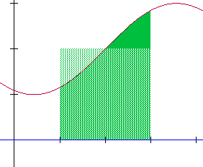**Mean Value Theorem**If *f* is continuous on the closed interval [a, b], then there exists a number *c* in the closed interval [a, b] such that

$$\int_{a}^{b}{f\left(x\right)dx=f(c)(b-a)}$$

In other words, there exists a *c* between [a, b] such that a rectangle of height h = f(c) would have the same area as the area found under the curve. The Mean Value Theorem only tells you f(c) exists; rearrange the equation to find the value of f(c).

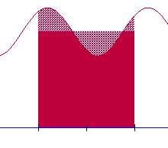**Average Value of a Function**  
If *f* is integrable on the closed interval [a, b], then the **average value** of *f* on the interval is

$$f\left(c\right)=\frac{1}{b-a}\int_{a}^{b}{f\left(x\right)dx}$$

**Example)**Find the average value of  on the interval [1, 4].

**The 2nd Fundamental Theorem of Calculus**If *f* is continuous on an open interval containing *a,* then, for every *x* in the interval:   
If the upper limit is a function, $\frac{d}{dx}\left[\int_{a}^{g(x)}{f\left(t\right)dt}\right]=f(g\left(x\right))∙g'(x)$ (chain rule)   
  
The upper limit must be the variable. Switch the limits if x is the lower limit. $\int_{x}^{a}{f\left(t\right)dt}=-\int_{a}^{x}{f\left(t\right)dt}$

The 2nd Fundamental Theorem of Calculus shows that if a function is continuous then it will have an antiderivative. The antiderivative may not be an elementary function.

An elementary function is written with one variable and made up of a finite number of arithmetic operations   
(+,-,÷,×), exponentials, logarithms, constants, and solutions of algebraic equations.

For example, $\int{e^{x^{2}}dx}$ does not have an elementary antiderivative, but it does have an antiderivative nonetheless.

**Examples)**Evaluate  Find the slope of $\int_{π/2}^{x^{3}}{\cos\left(t^{2}\right)dt}$ $\frac{d}{dx}\int_{sinx}^{2}{\left(\cos\left(t\right)+2\right)dt}$



The graph of a function *f* consists of a quarter circle and line segments.   
Let *g* be the function given by.

(a) Find .

b) Find the *x*-coordinate of each point of inflection of the graph of *g* on . Justify your answer.