Calculus Section 5.1 The Natural Log  
-Develop and use properties of the natural logarithmic function  
-Find derivatives of functions involving the natural log

Homework: page 325 #’s 10, 12-14, 19, 21, 23, 29-31, 41-49 odd, 61, 62, 67, 83, 99-102

**Definition of the Natural Logarithmic Function**The natural logarithmic function is defined by:

The domain of the natural logarithmic function is the set of ____________________________________.

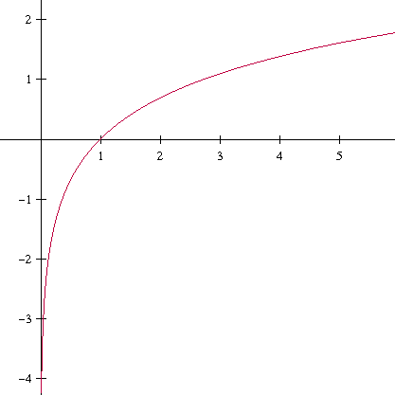 **Properties of the ln function**

**Logarithmic Properties**If *a* and *b* are positive numbers and *n* is rational, then the following properties are true.

1. 
2. 
3. 
4. 

**Derivative of the Natural Log Function**Let *u* be a differentiable function of x.

1)  2)  3) 

**Examples)**1) Find the eq. of the tangent line to $y=\ln{(2x)}$ 2) $\frac{d}{dx}[\ln{5}]$  
when x = 2.

3) Find for 4) Find for

5) Find the 2nd derivative of $\ln\left(\ln\left(x\right)\right)$ 6) Find  if 