Calculus Section 7.2 Volume by Cross Sections  
-Find the volume of a solid with known cross sections

Homework: Volume by Cross Sections Worksheet

We have defined the integral of a function as a way to find the ______________________. However, there are other applications of the integral. One application that is related to area is finding the volume of a 3-dimensional surface.

One method to do this involves cross sections. Two-dimensional cross sections can be stacked on top of (or next to) each other to create a 3-d figure. We use the area between two curves to represent the base of the cross sectional shape.

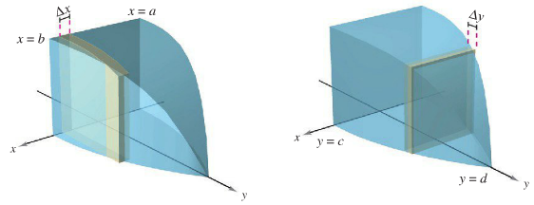

**Volumes of Solids with Known Cross Sections**1) For cross sections of area A(x) taken perpendicular to the x-axis: Volume = 

2) For cross sections of area A(y) taken perpendicular to the y-axis: Volume = 

Where A(x) and A(y) are the known geometric formulas for the area of a shape. For instance, a square cross section has A(x) = s2, a semi-cirlce would be A(x) = ½πr2, and an equilateral triangle is A(x) = $\frac{\sqrt{3}}{4}s^{2}$.

**Example) Use the following region for each cross section.**Find the volume of a triangular shaped solid whose base is the region bounded by the lines f(x) = 1 – x/2, g(x) = -1 + x/2, and x = 0 using…  
a) Square cross sections perpendicular to the x-axis b) Square cross sections perp. to the y-axis

c) Rectangles of h = 4 perp. to the x-axis d) Rectangles where h(x) = 4 – x perp. to x-axis

e) Semicircles perp. to the x-axis f) Isolsceles right triagles whose leg is bounded  
by the region and perp. to the x-axis

g) Isosceles right triangles where the hypotenuse h) Equilateral triangle perp. to the y-axis.  
is bound by the region and perp. to the x-axis.