Calculus Section 7.4 Arc Length and Surfaces of Revolution
-Find the length of an arc
-Find the area of a surface of revolution
Homework: page 473 #’s 3, 11, 13, 21, 38, 43, 44, 47
Arc Length
The length of a curve is found by summing small segments using distance formula.
(x₀, y₀)
(x₁, y₁)
∆x
∆y
$$d=\sqrt{{\left(∆x\right)}^{2}+{\left(∆y\right)}^{2}}$$
$$d=\sqrt{{\left(∆x\right)}^{2}+{\left(∆y\right)}^{2}{\left(\frac{∆x}{∆x}\right)}^{2}}$$
$$d=\sqrt{{\left(∆x\right)}^{2}+{\left(\frac{∆y}{∆x}\right)}^{2}{\left(∆x\right)}^{2}}$$
$$d=\sqrt{{\left(∆x\right)}^{2}\left(1+{\left(\frac{∆y}{∆x}\right)}^{2}\right)}$$
$$d=\sqrt{1+{\left(\frac{∆y}{∆x}\right)}^{2}}\left(∆x\right)$$
$$d=\sqrt{1+{f'(x)}^{2}}\left(∆x\right)$$
$$length=\int_{a}^{b}{\sqrt{1+{f'(x)}^{2}}dx}$$
Examples)
Find the arc length of f(x) = x² on the interval [-1, 1]. Find the arc length of y = $\frac{3}{2}x^{2/3}$ on the interval [1, 8].

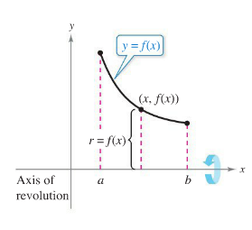
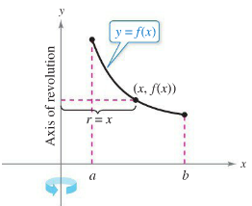
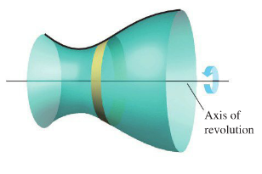
Surface of Revolution
We can combine the concepts of volume by rotation and arc length
to find the surface area of a solid of revolution.
Horizontal axis of rotation Vertical axis of rotation
$$S=2π\int_{a}^{b}{r(x)\sqrt{1+{f'(x)}^{2}}dx} S=2π\int_{c}^{d}{r(y)\sqrt{1+{g'(y)}^{2}}dy}$$

where r(x) and r(y) are perpendicular to the axis of revolution.
Example)
Find the area of the surface of revolution formed by revolving the graph of f(x) = x³ on the interval [0, 1] about the x-axis.

Example)
Find the area of the surface formed by revolving the graph of f(x) = x² on the interval [0, $\sqrt{2}$ ] about the y-axis.

Gabriel’s Horn
Gabriel’s Horn is the name given to the 3-d figure created when the function $f\left(x\right)=\frac{1}{x}$ on the interval [1, ∞] is revolved about the x-axis. Gabriel’s Horn is a paradox because it has finite volume yet infinite surface area.

