AP Calculus AB Review Transcendentals, Diff Eqs., Area/Volume Name: __________________
Determine the derivative of the following functions.
1) f(x) = ln(x⁴ + 8) 2) f(x) = $e^{secx}$ 3) g(x) = tan(e^{2x})

4) $\int_{ln⁡(2x)}^{1}{f\left(t\right)dt}$ 5) y = arctan(3x – 1) 6) f(x) = 2^{4x} – cot(3x)

Evaluate the following integrals.
7) $\int{\frac{sec^{2}x}{tanx}dx}$ 8) $\int{\frac{1}{xlnx}dx}$ 9) $\int{e^{5x}dx}$

10) $\int{\frac{e^{x}}{1+e^{x}}dx}$ 11) $\int{\frac{e^{x}}{1+e^{2x}}dx}$ 12) $\int{tan⁡(4x)}dx$

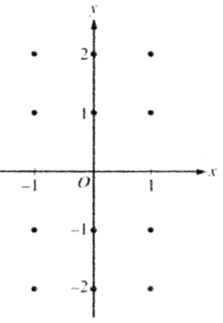
13) Consider the differential equation $\frac{dy}{dx}=-\frac{2x}{y}$.
(a) On the axes provided, sketch a slope field for the given differential equation
at the twelve points indicated.

(b) Let y= f(x) be the particular solution to the differential equation with the initial condition f(1) = -1. Write an equation for the line tangent to the graph of f at (1, -1) and use it to approximate f(1.1).

(c) Is the approximation for f(1.1) found in part (b) an underestimate or overestimate? Justify your reasoning.

(d) Find the particular solution y = f(x) to the given differential equation with the initial condition f(1) = -1.

14) Find the particular solution y = f(x) to the differential equation $\frac{dy}{dx}=x^{2}(y-1)$ with the initial condition f(0) = 3.

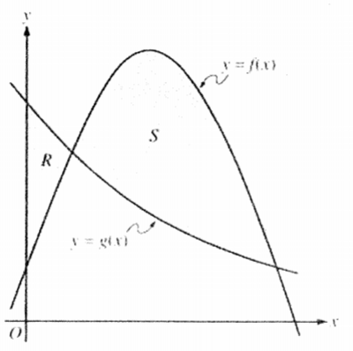
15) Let f and g be the functions given by f(x) = $\frac{1}{4}+\sin\left(πx\right)$ and g(x) = $4^{-x}$. Let R be the shaded region in the first quadrant enclosed by the y-axis and the graphs of f and g, and let S be the shaded region in the first quadrant enclosed by the graphs of f and g, as shown in the figure below.
(a) Find the area of R.

(b) Find the area of S.

(c) Find the volume of the solid generated when S is revolved about the horizontal line y = -1.

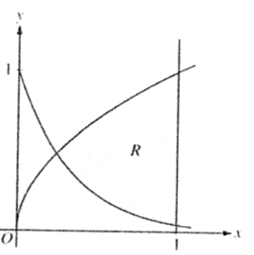
16) Let R be the shaded region bounded by the graphs of $y=\sqrt{x}$ and $y=e^{-3x}$ and the vertical line x = 1, as shown in the figure below.
(a) Find the area of R.

(b) Find the volume of the solid generated when R is revolved about the horizontal line y = 1.

(c) The region R is the base of a solid. For this solid, each cross section perpendicular to the x-axis is a rectangle whose height is 5 times the length of its base in region R. Find the volume of this solid.

17) The radius r of a sphere is increasing at a constant rate of 0.04 centimeters per second. (Note: The volume of a sphere with radius r is $V=\frac{4}{3}πr^{3}$.
(a) At the time when the radius of the sphere is 10 centimeters, what is the rate of increase of its volume?

(b) At the time when the volume of the sphere is 36π cubic centimeters, what is the rate of increase of the area of a cross section through the center of the sphere?

