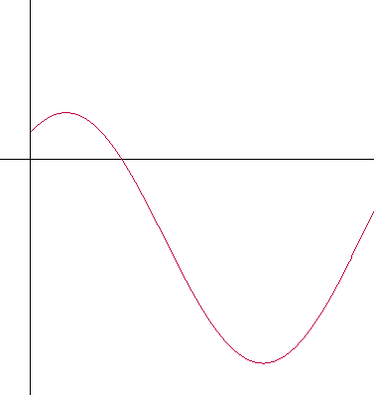**Practice Integration Problems #2**  Name:______________________________

y

1) The figure to the right shows the graph of the velocity of a particle   
moving along the x-axis as a function of time. If the particle is at the   
origin when t = 0, then which of the marked points is the particle   
furthest from the origin?

E

t

C

B

A

(A) A (B) B (C) C  
  
(D) D (E) E

D

2) 

(A)  (B)  (C) 

(D)  (E) 

3) Let f(x) be the function defined by f(x) = . The value of 

(A) 3/2   
(B) 5/2   
(C) 3   
(D) 7/2   
(E) 11/2

4) The average value of the function f(x) = on the closed interval [-4, 0] is

(A) -1/2sin(2) (B) -1/4sin(2) (C) 1/2cos(2) (D) 1/4sin(2) (E) 1/2sin(2)

5) Let R(t) represent the rate at which water is leaking out of a tank, where t is measured in hours. Which of the following expressions represents the total amount of water in gallons that leaks out in the first three hours?

(A) R(3) – R(0) (B)  (C)  (D)  (E) 

6) Suppose that f(x) is an even function and let = 5 and = 1. What is ?  
(A) – 5   
(B) -4   
(C) 0   
(D) 4   
(E) 5

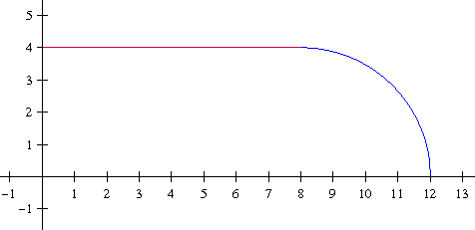7) As shown in the figure to the right, the function f(x) consists of  
a line segment from (0, 4) to (8, 4) and one-quarter of a circle with   
a radius of 4. What is the average (mean) value of this function  
on the interval [0, 12]? (calc.)

(A) 2  
(B) 3.714  
(C) 3.9  
(D) 22.283  
(E) 41.144

8) If f is the function defined by f(x) = and g is an antiderivative of f such that g(5) = 7, then g(1) ≈ (calc.)

(A) –3.882  
(B) –3.557   
(C) 1.710  
(D) 3.557  
(E) 3.882

9) If f and g are continuously differentiable functions defined for all real numbers, which of the following definite integrals is equal to f(g(4)) – f(g(2))?

(A)  (B)  (C)    
(D)  (E) 

10) If the substitution u = is made, the integral =

(A)  (B)  (C) 

(D)  (E) 

11) If , then k must be

(A) -3  
(B) -2  
(C) 1  
(D) 2  
(E) 3

12) 

(A) sin(x6) – sin(x2) (B) 6x2sin(x3) – 2sin(x) (C) 3x2sin(x6) – sin(x2)

(D) 6x5sin(x6) – 2sin(x2) (E) 2x3cos(x6) –2 cos(x2)

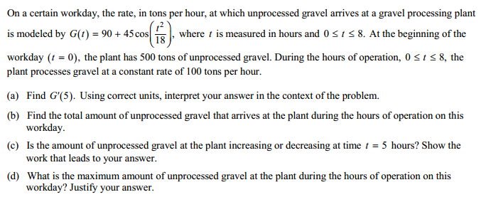  
2013 Free Response Question 1 (calc.)