Calculus Section 1.4 Continuity and One-Sided Limits

* Determine continuity at a point and continuity on an open interval.

Homework: pages 79-81   
#’s 1-13 odd, 22, 27, 28, 103, 118

* Determine one-sided limits and continuity on a closed interval.

**Continuity at a Point and on an Open Interval**

For a function to be **continuous** is has to be unbroken. This means that there are no holes, jumps, or gaps. In other words, you must be able to draw the graph of the function without picking up your pencil.

Here are three examples of functions that are not continuous.  
1) f(c) is not defined 2)  3) 

**Definition of Continuity***Continuity at a point:*  A function *f* is **continuous at c** if the following three conditions are met:

**1)  
2)  
3)**

*Continuity on an Open Interval:* A function is **continuous on an open interval (a,b)** if it is continuous at each point in the interval. A function that is continuous on the entire real line (-∞, ∞) is **everywhere continuous**.

Examples

1.  2)   3) 

If a function is not continuous, then we call it **discontinuous**. Discontinuities come in two types: **removable** and **nonremovable**. Removable discontinuities could be made continuous by appropriately defining f(c) so that the function is continuous.

**Examples**

Nonremovable: Removable:

**One-Sided Limits**

A limit can be evaluated from just a single side of a point, c. These are called the right-hand and left-hand limits. The right-hand limit evaluates the limit as the function approaches the point c from values greater than c,. The left-hand limit evaluates the limit as the function approaches the point c from values less than c,.

Note: One-sided limits can occur where normal limits do not.

Example) Evaluate the following:

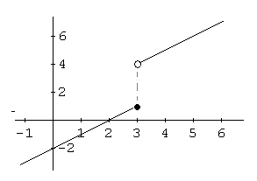

1. =
2. =
3. =
4. =

Example) Evaluate the following limits:

1. = b)  c) 

**Existence of a Limit**

Let *f* be a function and let *c* and *L* be real numbers. The limit of f(x) as x approaches c is L if and only if:

We can use this idea to extend the definition of continuity on an open interval to a definition of continuity on a closed interval.

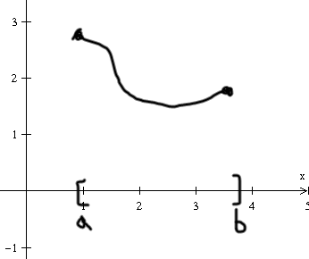A function *f* is **continuous on the closed interval [a,b]** if:  
1) it is continuous on the open interval (a,b)  
2)   
3) 

The function f is **continuous from the right** at a and **continuous from the left** at b.