Calculus Section 2.1 and 2.2 Tangent Lines

-Write the equation of a tangent line for a function at a point.  
-Find horizontal tangent lines from the derivative.  
-Graphs and derivatives

Homework: Page 103 #’s 25-33 odd, 34, 37, 39, 42  
Page 115 #’s 57-61 odd, 80

**Finding the equation of the tangent line of a function at a point.**To find the equation of a tangent line at a point, follow these steps:  
 1) find the equation for slope by taking the derivative  
 2) substitute x into the derivative to find the slope  
 3) write an equation using the slope in point-slope form

Examples)  
1)  at (1,0) 2)  at (-1,-2)

**Finding a horizontal tangent line**To find where a function has a horizontal tangent line:  
 1) take the derivative of the function  
 2) set the derivative equal to _____________.

Examples) Find where the graph has a horizontal tangent line (if any exist)  
1)  2)  3) 

**Differentiability and Continuity**There is an alternate definition of a derivative using limits that is useful when investigating the relationship between differentiability and continuity. The derivative of *f* at *c* is . The existence of this limit requires that the one-sided limits exist and are equal:  
 

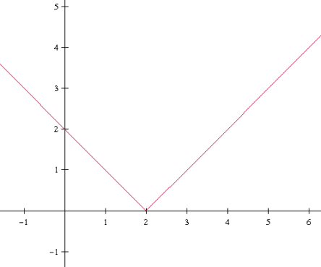**A Graph with a Sharp Turn**Consider the function f(x) = |x-2|

  
and  
 

Since the one-sided limits are not equal, we can conclude f(x) is _____________________ and has no tangent line at x=2. This is even though f(x) = |x-2| is everywhere continuous.

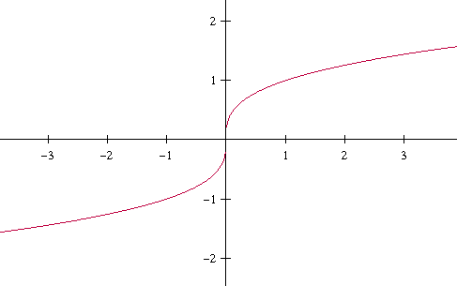**A Graph with a Vertical Tangent Line**Let . f(x) is continuous at x = 0 as shown in the drawing, but because the limit

=

**Differentiability Implies Continuity**If *f* is differentiable at x = c, then *f* is continuous at x = c.

This does not mean that if a function is continuous it is also differentiable. Graphs with either a ____________________ or a _________________________ are not differentiable at the point where either of those actions occur.