**2.5 – 2.6 AP Questions**  Name: ____________________________________

**2005 Form B AP Calculus Free-Response Questions (Non-Calc)**

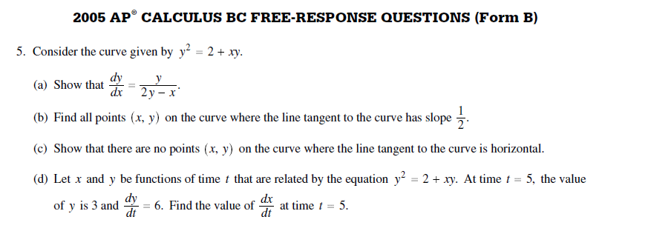

**2004 AP Calculus Free-Response Question (Non-Calc)**

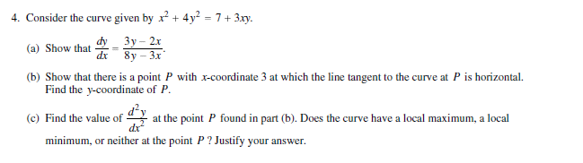

**2003 AP Calculus Free-Response Question (Non-Calc)**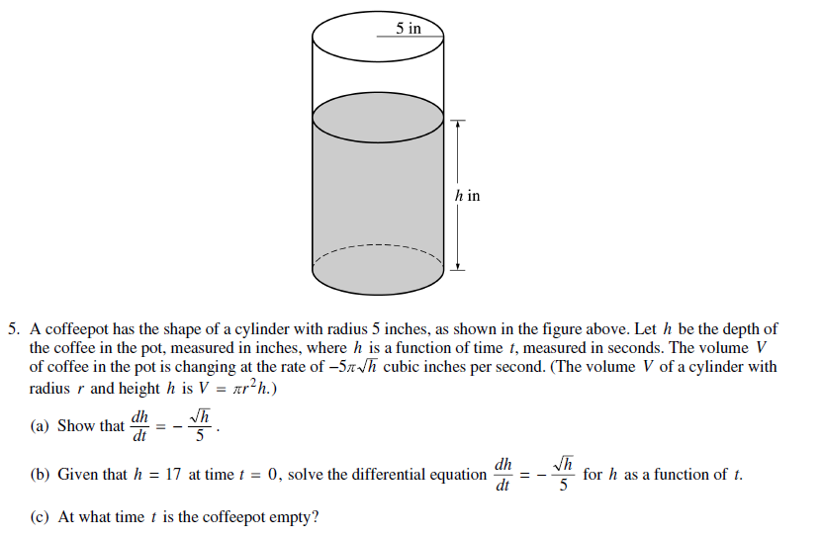

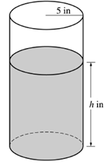

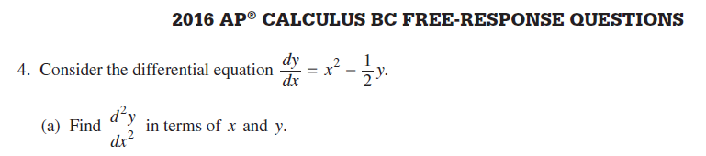**2016 AP Calculus Free-Response Questions (Non-Calc)**

**2016 AP Calculus Free-Response Question (Non-calc).**

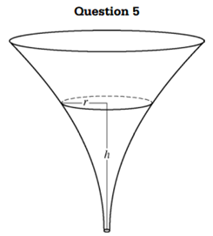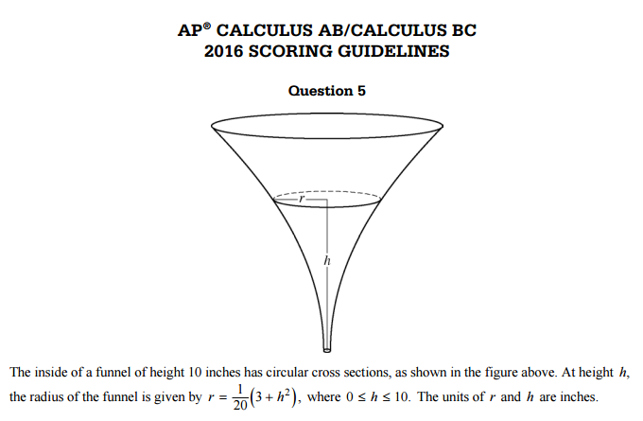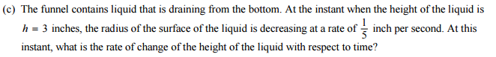

When the height of a cylinder is 12 cm and the radius is 4 cm, the circumference of the cylinder is increasing at a rate of cm/min, and the height of the cylinder is increasing four times faster than the radius. How fast is the volume of the cylinder changing?

1. 
2. 
3. 
4. 
5. 

Find if .

A) $\frac{4-3y}{2y-3x}$ B) $\frac{3x-4}{2x}$ C) $\frac{3y-x}{2}$ D) $\frac{3y-4}{2y-3x}$ E) $\frac{4+3y}{2y+3x}$

The radius of a circle is decreasing at a constant rate of 0.1 centimeters per second. In terms of the circumference, C, what is the rate of change of the area of the circle, in square centimeters per second?

1. 
2. 
3. 
4. 

(E) 