Calculus Section 3.3 The First Derivative Test

Homework: Page 186 #’s 9 – 14, 57 – 60, 91 – 96

-Determine intervals on which a function is increasing or decreasing  
-Apply the First Derivative Test to find relative extrema on a function

**Increasing and Decreasing Functions**Let *f* be a function that is continuous on the closed interval [a, b] and differentiable on the open interval (a, b).   
 1) If ________________ for all x in (a, b), then *f* is **increasing** on [a, b].  
 2) If ________________ for all x in (a, b), then *f* is **decreasing** on [a, b].  
 3) If ________________ for all x in (a, b), then *f* is **constant** on [a, b].

**Steps for Finding Increasing/Decreasing/Constant** 1) Find critical numbers  
 2) Write intervals between those critical numbers  
 3) Substitute a value from each interval into to test it  
 4) Indicate how the function behaves from the rules above

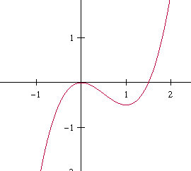**Example)**Find the open intervals on which is increasing or decreasing.

**The First Derivative Test**Let *c* be a critical number of a function *f* that is continuous on an open interval I containing *c*. If *f* is differentiable on the interval, except possibly at *c*, then f(c) can be classified as follows:

1. If changes from negative to positive at *c*, then *f* has a _______________________ at (c, f(c)).
2. If changes from positive to negative at *c*, then *f* has a _______________________ at (c, f(c)).
3. 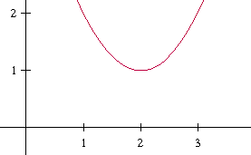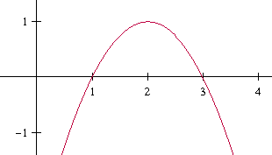If is positive on both sides of *c* or negative on both sides of *c*, then *f*(c) is neither a relative maximum nor a relative minimum.

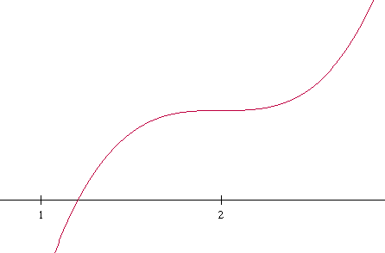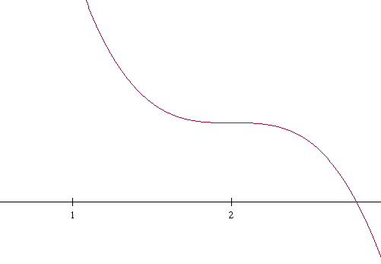

**Examples)**Find the relative extrema and inc./dec. intervals of Find the relative extrema and inc./dec. intervals of  
 on [0, 2π]. 