Calculus Section 4.3 Midpoint and Trapezoidal Sums
-Understand the definition of a Riemann Sum
-Use sums to find the area under a curve
Homework: Riemann Sum worksheet
Midpoint Sum
The left Riemann sum used the f(x) on the left side of each rectangle for its height.
The right Riemann sum used the f(x) on the right side of each rectangle for its height.
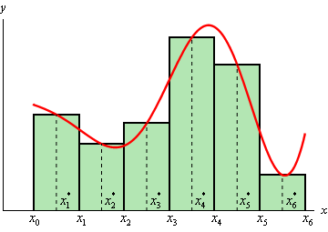
A midpoint sum uses the midpoint of each rectangle as its height.

The midpoint sum both over and underestimates for each rectangle. On average, the midpoint is more accurate than a left or right Riemann sum.

Ex) Use the midpoint sum to find the area under the curve y = x² + 1 on [0 , 2] with 4 even subintervals.

Ex) Use a midpoint sum with 3 equal partitions to estimate the area under the curve shown in the table below.
x | 1 | 2 | 3 | 4 | 5 | 6 | 7
f(x) | 0 | 5 | 7 | 8 | 14 | 19 | 21

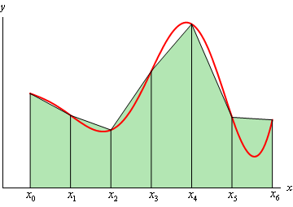
Trapezoidal Sums
Another approximation sum uses trapezoids. Area of a trapezoid is: $A=\frac{1}{2}\left(b_{1}+b_{2}\right)h$
h
b₂
b₁

Ex) Use a trapezoidal sum to approximate the area under the curve y = x² + 1 on [0, 2] with 4 equal intervals.

Ex) The acceleration of a particle is given in the table below. If the initial velocity of the particle is v(0) = 3, find the velocity of the particle at time t = 8.
t | 0 | 2 | 5 | 7 | 8
a(t) | 0 | 4 | 13 | 21 | 23

