**3.1 – 3.6 Practice AP Questions**  Name:______________________________

1) The graph of y = 3x2 – x3 has a relative maximum at

(A) (0,0) only

(B) (1,2) only

(C) (2,4) only

(D) (4,-16) only

(E) (0,0) and (2,4)

2) If the graph of f(x) = 2x2 + k/x has a point of inflection at x = -1, then the value of k is

(A) -2

(B) -1

(C) 0

(D) 1

(E) 2

3) What are all value of x for which the graph of is concave downward?  
(A) No values of x

(B) x < 4

(C) x > -4

(D) x < -4

(E) x > 4

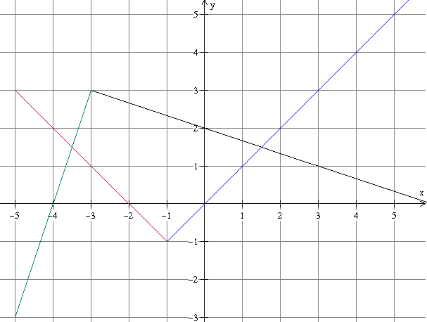4) The functions *f* and *g* are piecewise linear functions whose graph are shown below. If h(x) = f(x)g(x), then h’(3) =

g(x)

(A) -8/3

g(x)

(B) -1/3

(C) 0

f(x)

(D) 2/3

(E) 8/3

f(x)

5) At what value(s) of x does f(x) = x4 – 8x2 have a relative minimum?

(A) 0 and -2 only

(B) 0 and 2 only

(C) 0 only

(D) -2 and 2 only

(E) -2, 0, and 2

6) The function y = x4 + bx2 + 8x + 1 has a horizontal tangent and a point of inflection for the same value of x. What must be the value of b?

(A) -6

(B) -1

(C) 1

(D) 4

(E) 6

7) Let *f* be the function given by f(x) = x3. What are all value of c that satisfy the conclusion of the Mean Value Theorem on the closed interval [-1, 2]?

(A) 0 only

(B) 1 only

(C) 

(D) -1 and 1

(E) 

8) What are all values of x for which the function f(x) = x3 + 6x2 + 9x + 1 is increasing?

(A) (-∞, -3) only

(B) (-3, -1) only

(C) (-1, ∞) only

(D) (-∞, -3) U (-1, ∞)

(E) (-∞, -3) U (1, ∞)

9) If *f* is defined by , what are all the x-coordinates of the points of inflection of the graph of *f*?

(A) -2 only

(B) 0 only

(C) 2 only

(D) -2 and 0 only

(E) -2, 0, 2

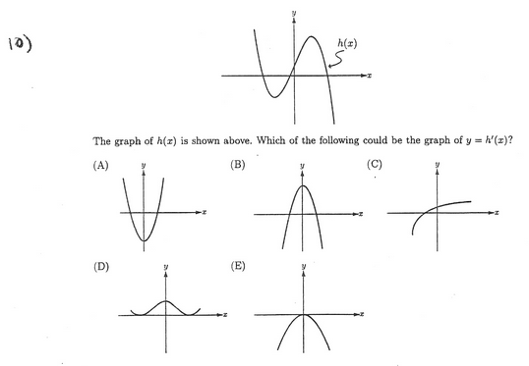10)

The graph of h(x) is shown above. Which of the following could be the graph of y = h ‘(x)?

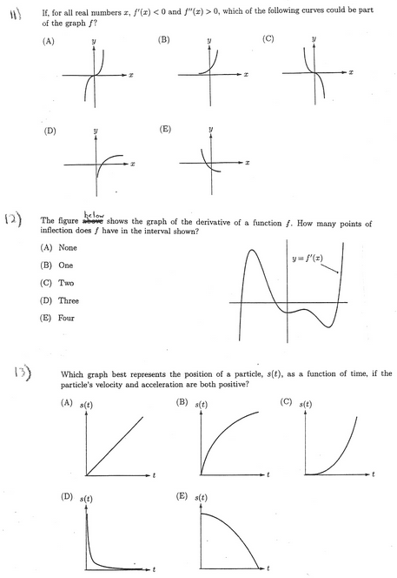11. If, for all real numbers x, f ‘(x) < 0 and f ‘’(x) > 0, which of the following curves could be part   
of the graph of f?

12) The figure below shows the graph of the derivative of a function f. How many points of inflection does f have in the interval shown?

(A) None

(B) One

(C) Two

(D) Three

(E) Four

13) Which graph best represents the position of a particle, s(t), as a function of time, if the particle’s velocity and acceleration are both positive?

14) Water is draining out of a rectangular tank whose base measures 50 x 10 cm and height measures 20 cm. The water level of the tank is changing by 0.1 cm every second. The water is draining into another rectangular tank whose base measures 30 x 20 cm and height measures 20 cm. How fast is the water level rising in the 2nd tank?