**AP Questions Parametric, Vector, Polar**  Name:________________________________________

1) A particle moves in the xy-plane so that its velocity vector at time *t* is $v\left(t\right)=〈t^{2}, sin⁡πt〉$ and the particle’s position vector at time t = 0 is $〈1, 0〉$. What is the position vector of the particle when t = 3?

(A) (9, 1/π) (B) (10, 2/π) (C) (6, -2π) (D) (10, 2π) (E) (10, 2)

2) Which of the following is an equation of the line tangent to the curve with parametric equations x = 3e-t, y = 6et at the point where t = 0?

(A) 2x + y – 12 = 0

(B) -2x + y – 12 = 0

(C) 2x + y – 6 = 0

(D) -2x + y – 6 = 0

(E) 2x + y = 0

3) A particle moves on the x-axis so that at any time t its velocity v(t) = sin2t subject to the condition x(0) = 0 where x(t) is the position function. Which of the following is an expression for x(t)?

(A) cost2t + ½

(B) -½sin2t + ½

(C) -½cos2t

(D) -½cos2t + ½

(E) -½cos2t – ½

4) (calc) Which of the following gives the area of the region enclosed by the graph of the polar curve r = 1 + cosθ?

(A)  (B)  (C) 

(D)  (E) 

5) The curve in the xy-plane is defined parametrically by the equation x = t2 + t and y = t2 – t. For what values of t is the tangent line to the curve horizontal?

(A) t = -1 (B) t = -½ (C) t = 0 (D) t = ½ (E) t = 1

2015 #2 (Calculator)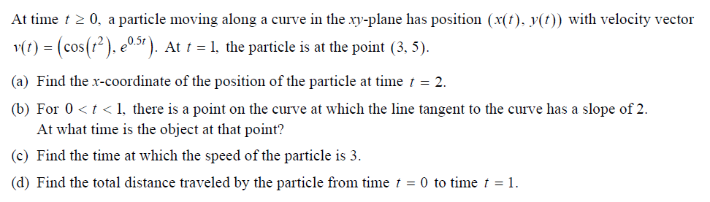

2014 #2 (Calculator)