**AP Questions Chapter 5** Name_______________________________________________

1) If , how many zeros does f ’(x) have on the closed interval [0, 2π]?

(A) 1 (B) 2 (C) 3 (D) 4 (E) 5

2) 

(A)  (B)  (C) 

(D)  (E) 

3) If y = x(lnx)2, then =

(A) 3(lnx)2

(B) (lnx)(2x + lnx)

(C) (lnx)(2 + lnx)

(D) (lnx)(2 + xlnx)

(E) (lnx)(1 + lnx)

4) 

(A) 3 – e2 (B) 3 – e4 (C) 5 – e2 (D) 5 – e4 (E) 10 –2e4

5) The function f(x) = tan(3x) has one zero in the interval [0, 1.4]. The derivative at this point is (calc.)

(A) 0.411

(B) 1.042

(C) 3.451

(D) 3.763

(E) undefined

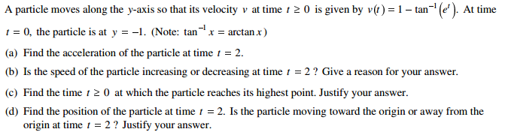6)

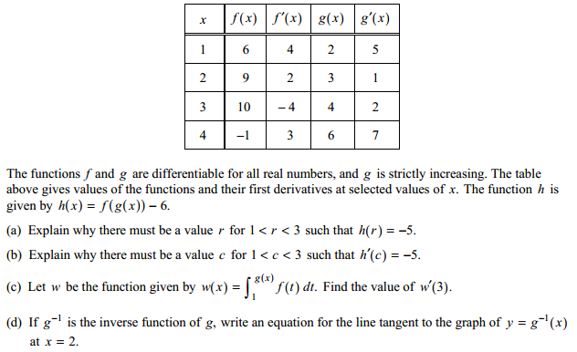7)