**AP Questions Chapter 7**

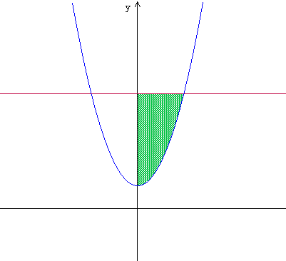1) For the figure to the right, the area of the shaded region is

y = 5

(A) 14/3 (B) 16/3 (C) 28/3

y = x2 + 1

(D) 32/3 (E) 65/3

2) If, for all real numbers x, f(x) = g(x) + 5, then on any interval [a, b] the area of the region between the graphs of f(x) and g(x) is

(A) 5 (B) 5a + 5b (C) 5b – 5a (D) 5a – 5b (E) 5ab

3) The region in the first quadrant enclosed by the graphs y = x and y = 2sinx is revolved about the x-axis. The volume of the solid generated is

(A) 1.895

(B) 2.126

(C) 5.811

(D) 6.678

(E) 13.355

4) The area of the region between the graph of y = 3x2 + 2x and the x-axis from x = 1 to x = 3 is

(A) 36 (B) 34 (C) 31 (D) 26 (E) 12

5) The base of a solid is the region in the first quadrant bounded by the line x + 2y = 4 and the coordinate axes. What is the volume of the solid if every cross section perpendicular to the x-axis is a semicircle?

(A)  (B)  (C) 

(D)  (E) 

6) The region in the first quadrant enclosed by the x-axis, the line x = π, and the curve y = cos(cos(x)) is rotated about the x-axis. What is the volume of the solid generated?

(A) 1.921 (B) 3.782 (C) 6.040 (D) 8.130 (E) 23.781

7) The region bounded by the x-axis and the part of the graph of y = cosx between x = 0 and x = π/2 is divided into two regions by the line x = c. If the area of the region for 0 ≤ x ≤ c is equal to the area of the region for c ≤ x ≤ π/2, the c must be

(A)  (B)  (C)  (D)  (E) 

8) The region enclosed by the line x + y = 1 and the coordinate axes is rotated about the line y = -1. What is the volume of the solid generated?

(A)  (B)  (C)  (D)  (E) 

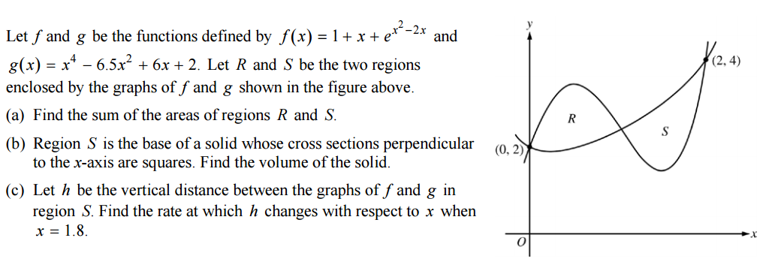9) 2015 Question #2 Calculator

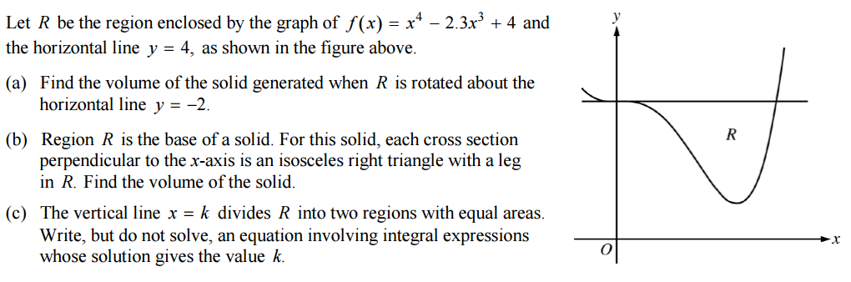10) 2014 Question #2 Calculator