**AP Questions Tay/Mac #2** Name:__________________________________

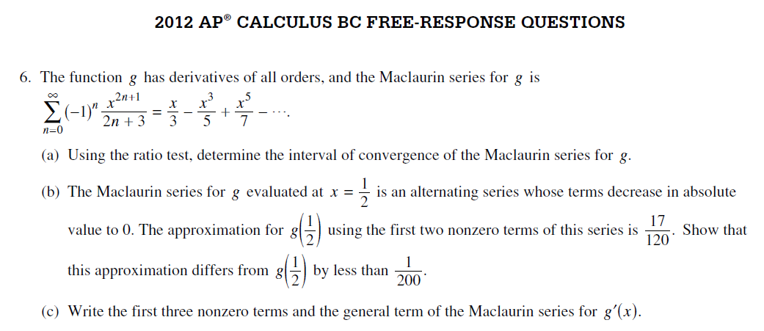

2012 AP Test

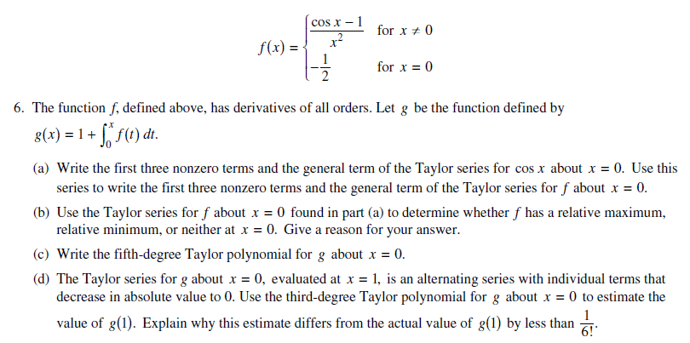

2010 AP Test

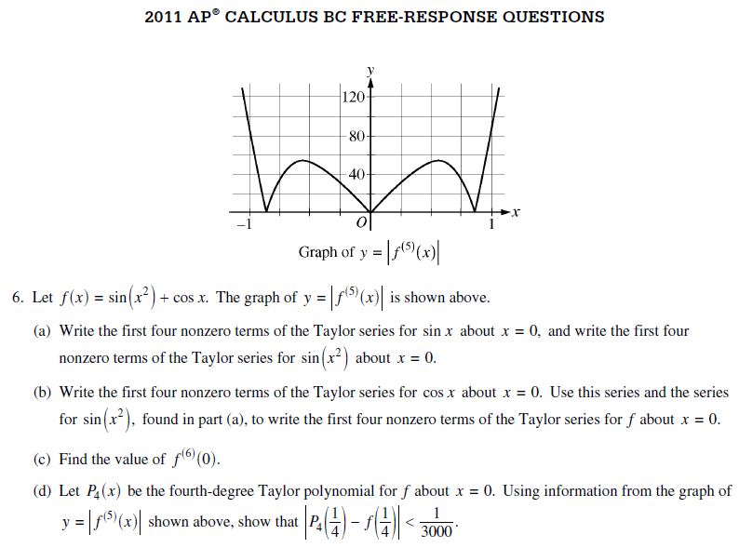

2011 AP Test