Calculus AB Review Limits and Derivatives Name: ______________________________
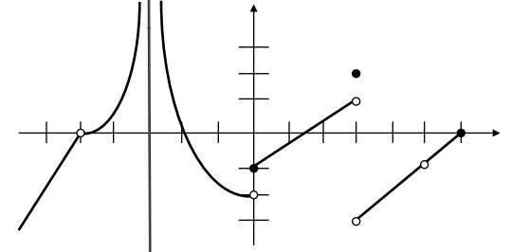
1) Answer the following using the graph of f(x) shown below.
(a) f(0) =
(b) f(3) =
(c) $\lim_{x→-5}{f(x)}$ =
(d) $\lim_{x→0^{+}}{f(x)}$ =
(e) $\lim_{x→3^{-}}{f(x)}$ =
2) Let $f\left(x\right)=\left\{\begin{aligned}3x^{2}+1,x<1 \\ 4x, x≥1 \end{aligned}\right.$. Which of the following is true?
I. f(x) is continuous at x = 1
II. f(x) is differentiable at x = 1
III. $\lim_{x→1^{-}}{f(x)}=\lim_{x→1^{+}}{f(x)}$
(A) I only (B) II only (C) III only (D) I and III only (E) II and III only
3) $\lim_{h→0}{\frac{cos\left(\frac{π}{6}+h\right)-cos\left(\frac{π}{6}\right)}{h}=}$
(A) Does not exist (B) 1/2 (C) -1/2 (D) $\sqrt{3}$/2 (E) $-\sqrt{3}$/2

4) Find the value of the limit: $\lim_{h→0}{\frac{\sqrt{tan\left(2x+2h\right)}-\sqrt{tan⁡(2x)}}{h}}$

5) Let f be a differentiable function with f(2) = 3 and f ‘(2) = -5, and let g be the function defined by
$g\left(x\right)=x∙f(x)$. What is the equation for the line tangent to the graph of g at the point where x = 2?

Find the derivatives of the following functions.
6) f(x) = (3x² + 7)(x² – 2x + 3) 7) f(x) = $\sqrt{x}∙sinx$

8) f(x) = 3x²sec³x 9) f(x) = $\frac{x^{4}+x}{\tan^{2}x}$

10) Given the equation y = sin(3x + 4y), find $\frac{dy}{dx}$.

11) Suppose that f and g are twice differentiable functions having selected values given in the table below.
x | f(x) | f'(x) | g(x) | g'(x)
1 | 5 | 4 | 2 | 7
2 | 8 | 6 | -6 | -4
If h(x) = f(g(x)), what is the value of h’(x) at the point where x = 1?

12) A particle moves along the x-axis according to the position function x(t) = 3sin(2t) + 1.
(a) Determine the instantaneous velocity of the particle at t = π. Which direction is the particle moving?

(b) What is the acceleration of the particle at t = $\frac{π}{4}$ ?

(c) Is the particle speeding up or slowing down at t = $\frac{π}{4}?$ Justify your answer.

13) If the nth derivative of y is denoted as y^{(n)} and y = -sinx, then y⁽¹⁴⁾ is the same as
(A) y
(B) $\frac{dy}{dx}$
(C) $\frac{d^{2}y}{dx^{2}}$
(D) $\frac{d^{3}y}{dx^{3}}$
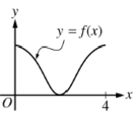
14)

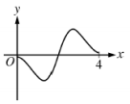
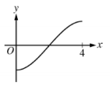
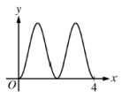
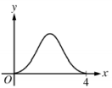
The graph of y = f(x) on the closed interval [0, 4] is shown above. Which of the following could be the graph of y = f ’(x)?
(A) (B) (C) (D)

t (hours) | 0 | 1 | 3 | 4 | 7 | 8 | 9
L(t) (people) | 120 | 156 | 176 | 126 | 150 | 80 | 0
15)

Concert tickets went on sale at noon (t = 0) and were sold out within 9 hours. The number of people waiting in line to purchase tickets at time t is modeled by a twice-differentiable function L for 0 ≤ t ≤ 9. Values of L(t) at various times t are shown in the table above.
(a) Use the data in the tale to estimate the rate at which the number of people waiting in line was changing at 5:30 P.M. (t = 5.5). Show the computations that lead to your answer. Indicate units of measure.

(b) For 0 ≤ t ≤ 9, what is the fewest number of times at which L’(t) must equal 0? Give a reason for your answer.

(c) Is there a time on the interval [1, 4] where the rate at which the number of people waiting in line was decreasing at a rate of 10 people per hour? Justify your answer.

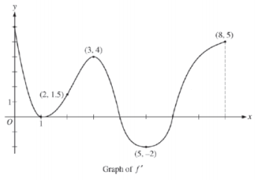
16) The figure below shows the graph of f ‘, the derivative of a twice differentiable function f, on the closed interval 0 ≤ x ≤ 8. The graph of f ‘ has horizontal tangent lines at x = 1, x = 3, and x = 5, and the function f is defined for all real numbers.
(a) Find all values of x on the open interval 0 < x < 8 for which the
function f has a local maximum. Justify your answer.

(b) On what open intervals contained in 0 < x < 8 is the graph of f both concave down and increasing? Explain your reasoning.

(c) Does the tangent line to the graph of y = f(x) at the point where x = 4 lie above or below the curve near that point? Justify your response.

