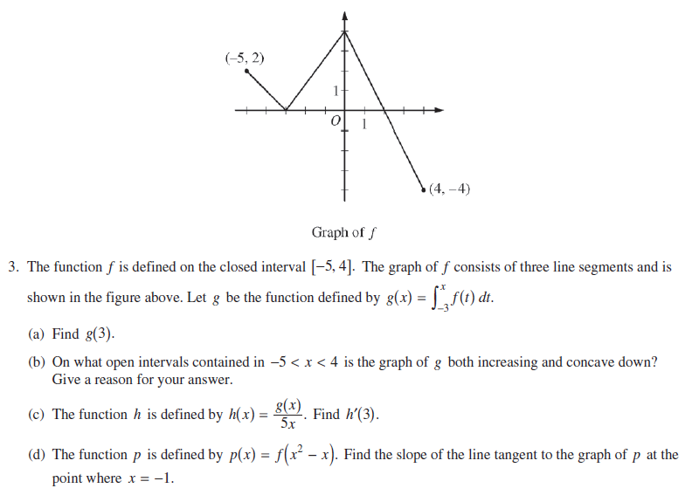
Chapter 4 AP Free Response Questions Name: ____________________________________
2014 #3 Non-Calc.

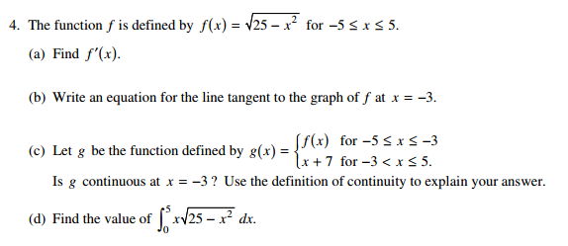
2012 #4 Non-Calc.

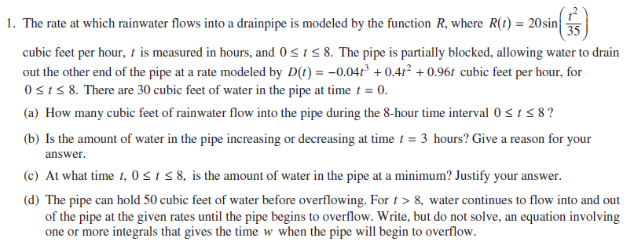
2015 #1 Calculator

2015 #3 Non-Calc.
